Lost and Found Mobile App Help Guide

Downloading the App

You can download the App “University Lot and Found” from the Apple Store or Google Play.

https://itunes.apple.com/gb/app/university-lost-and-found/id1050169692?mt=8

https://play.google.com/store/apps/details?id=com.kimsp.IncidentManagement

Log In

When you open the App for the first time you will need to Create an Account. To do this click on the “Create Account” link:
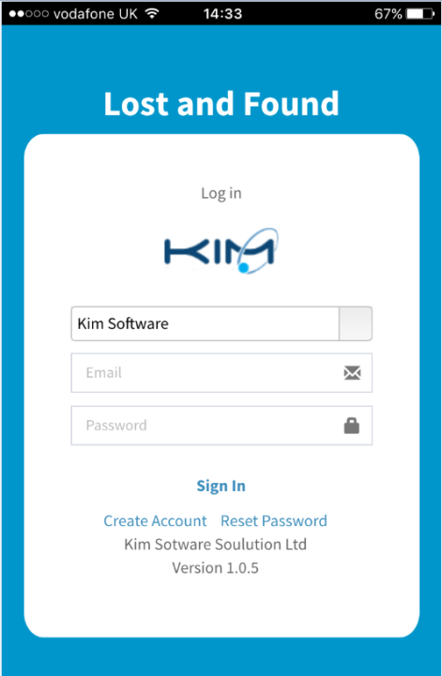

Create Account

Enter all the required information, these are indicated by the fields with a yellow background. You will need to ensure you select the correct Organisation i.e. University.
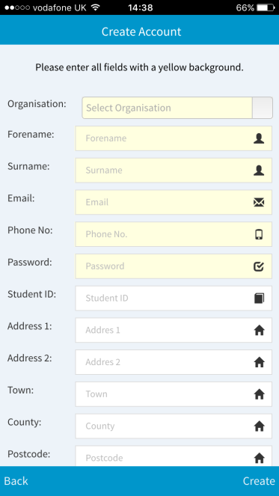
Once your account has been created then you can use the Sign In screen to start using the App. If your University is NOT in the list then this means your University has yet to subscribe to our Mobile App.

Forgotten Password

You can reset your by clicking on the Reset Password link from the Sign In screen. The system will reset your password and email you a new random generated password. After a successful log in, you can go to “My Profile” to update the password to one that you can easily remember.
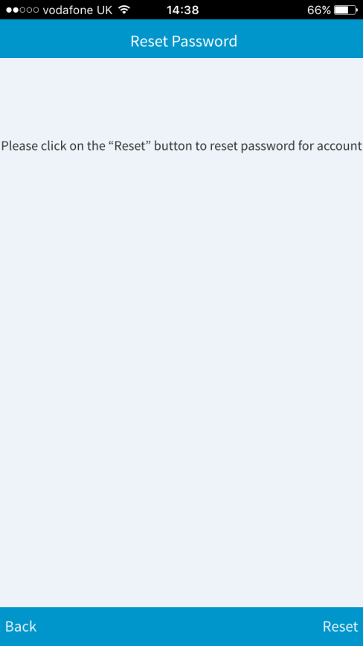

Dashboard

The dashboard allows you to carry out many tasks like editing your Profile, Managing your Pre-Registered Items and creating a Lost or Found Report.
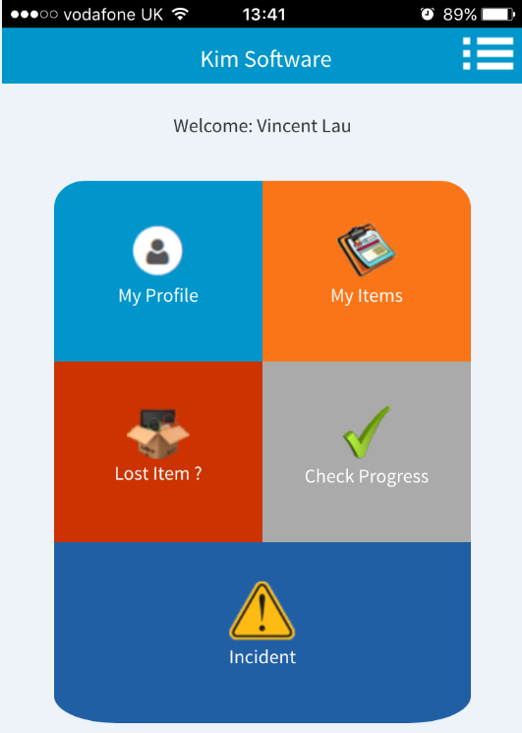

Navigation Menu

The Navigation Menu allows you to quickly move from one screen to another. For Example: If you are inside Edit My Profile you can use the Navigation Menu to quickly navigate to the Lost Record screen.
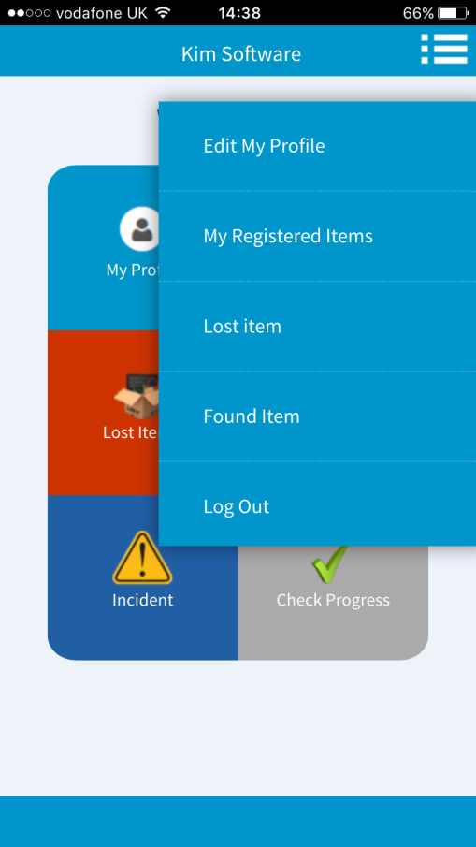

My Profile

You can edit and maintain your own profile from this screen. The system also uses this information when creating a Lost or Found Report. You can also change your password from here.
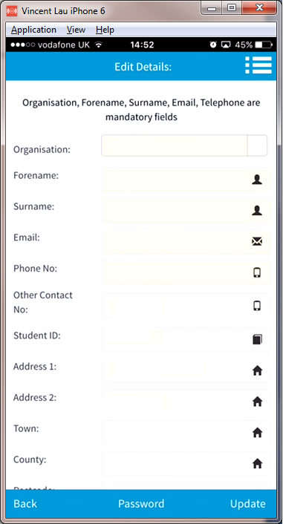.

My Items

You can now set up any worthy or valuable items that you wish the App to store. The key is to ensure you input enough information on the item, especially if the item has a unique serial no or IMEI No. You want to gather all the information about each item whilst you still have that item at hand. You can Edit and Remove Items from your List.
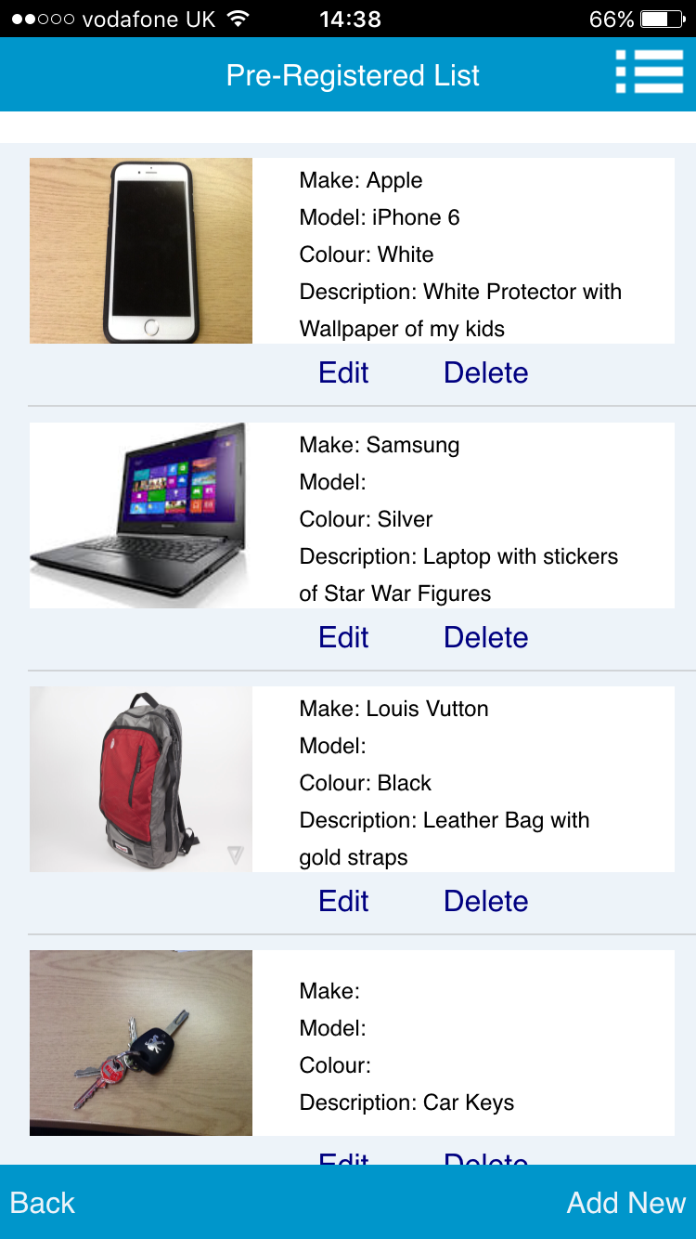

Adding Items
To add a new item simply click on the “Add New” link. If you wish to upload a photo of the item then click on the “Add Photo” link before you click on the “Save” link. However if you want to add a photo to your item later then you can do this via the “Edit” option.
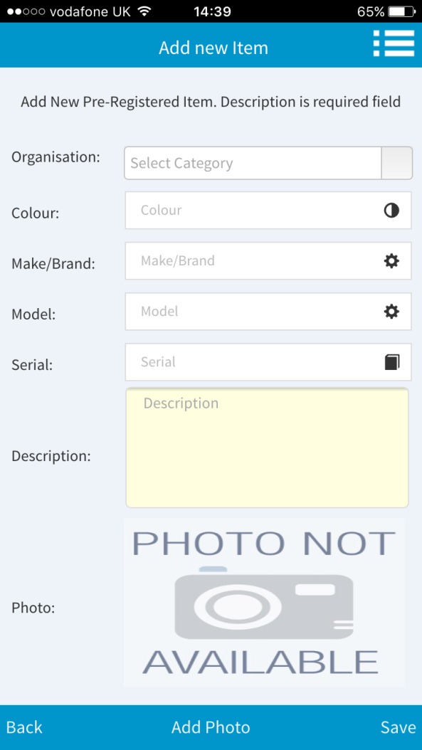
Editing Items
To edit an existing item simply click on the “Edit” button against the desired item.
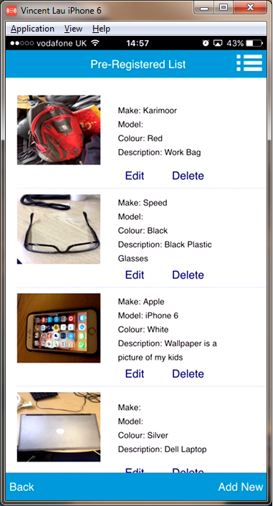
You can Edit the Item Information as well as upload a New Image.
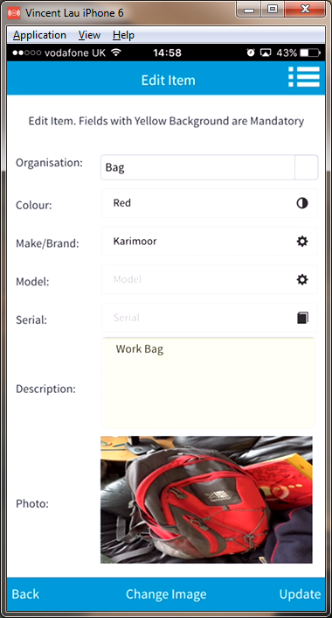
To change the image then click on the “Change Image” button and you will be presented with the option to “Take Photo” or “Get from Library”.
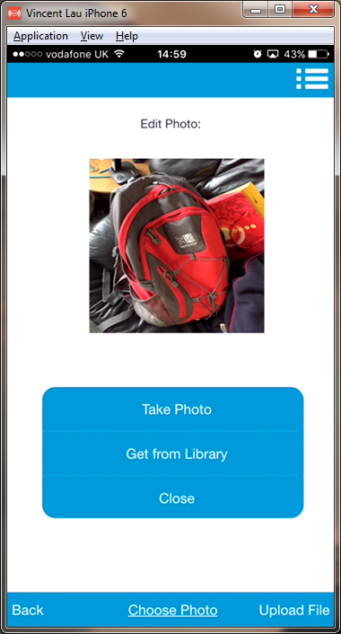
After the New Image has been selected the click on the “Upload File” button.

Submitting a Lost\Found Report
To submit a lost or found report then use the “Lost Item” or “Found Item” links from the Dashboard.
Step 1: will contain your personal information, which is automatically populated from the information supplied from your Profile. The fields are Read Only but you can change them via “Edit My Profile”.
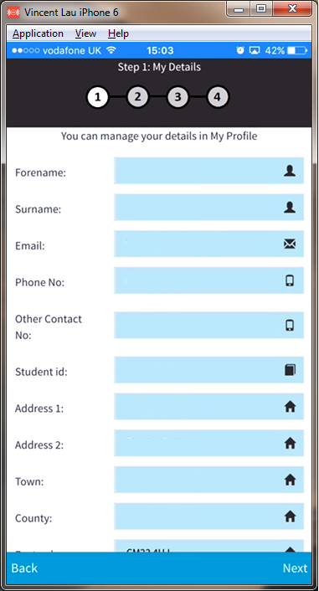
Simply click on the Next link.
Step 2: You will need to provide a Place\Location and select a Campus from the Drop Down. You can provide more information about the situation by using the “Comments” Area.
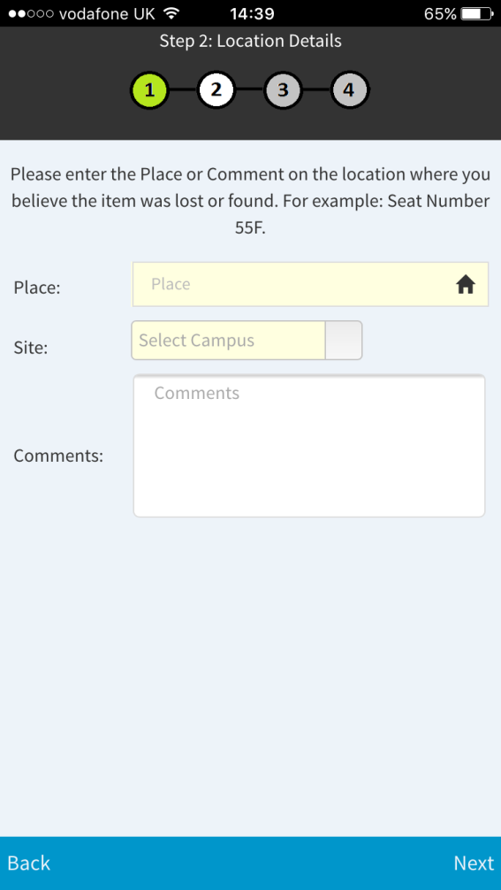
Step 3: If you have NO Pre-Registered Items then you will be required to input all the required fields marked in Yellow. However if you have Pre-Registered Items then simply click on the “Pre-Registered” link.
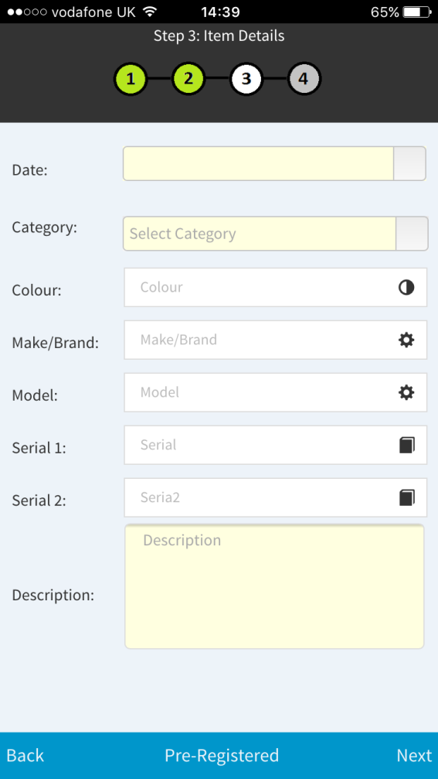

Step 4: If you have selected “Pre-Registered” then you will be presented with a list of your personal pre-registered items:
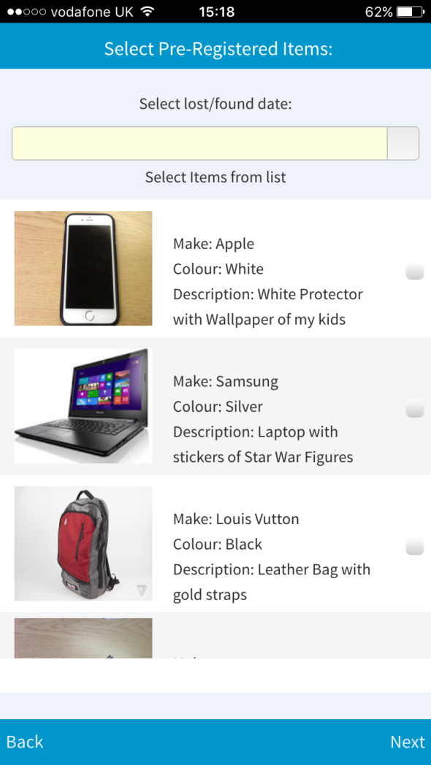
You can select one or multiple items depending on which items you have lost on this occasion. You must also provide a Date Lost. The system will generate a Lost Report using all the information i.e. Category, Make, Model, Colour, Serial No.
Finally you will receive a Reference Number and a confirmation Email. Please keep this safe.

Check Progress
You can check the progress on your Lost or Found reports from the “Check Progress” screen.
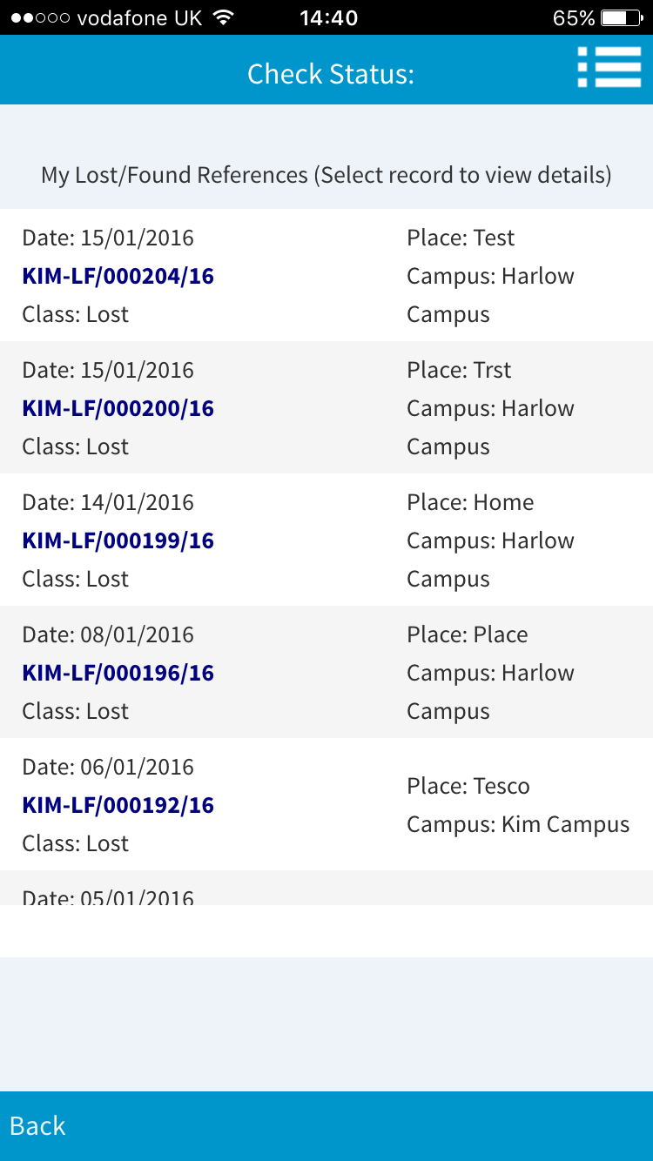
You can look at each record to see the Status of each Item:
